**HNBA**

**Automated commissions**

**&**

**Incentive management system**

**System Requirements Specification – (26-06-2017)**

Version 1.0

Table of Contents

1. Revision History 3
2. Introduction 3

Purpose 3

1. Overall Description 4

**3.1. Background** 4

3.1.1. Agent and Banc Assurance Management Process 4

3.1.2. Commission Calculation Process 5

3.1.2.1. Commission Calculate Rate Chart 6

3.1.2.2. Commission Calculate Rate Chart - Alternative 7

3.1.3. Overriding Commission Calculation Process 8

3.1.3.1 Overriding Commission Calculation Chart 9

3.1.4. Incentive Management Process 10

3.1.4.1. Banc assurance incentive process 10

3.1.4.2. Field Staff Incentive Process 11

3.1.4.3. FST allowance and target allowance 12

Group path level procedure GL/TL/AFM 13

Group path level procedure FM/AGFM/GFM 14

Group path level procedure SGFM 15 3.1.4.4. Group Incentive Criteria 16

3.1.4.5. Retainer Bonus GL/TL/AFM/FM/AGFM/ GFM/SGFM 17-18

**3.2 Objectives** **19**

3.2.1 Design Diagrams 19

3.2.1.1. Flow Chart 19

3.2.1.1.1. Agent and Banc Assurance Management 19

3.2.1.1.2. Data Gathering for Commission 20

3.2.1.1.3. Commission Calculation 21

3.2.1.1.4. Commission Overriding 22

3.2.1.2. User Interface Designs 23

3.2.1.2.1. Agent Personal Detail 23

3.2.1.2.2. Agent Other Detail 24

3.2.1.2.3. Agent Level Detail 25

3.2.1.2.4. Agent Commission / Commission Overriding Detail 26

3.3. Reports 27

3.4. System Integration 28

3.5. Unsolved issues 29

3.6. Assumptions 29

3.7. Annexures………………………………………………………………………………………………………………………… 30

# 1. Revision History

|  |  |  |  |
| --- | --- | --- | --- |
| Date | Version | Description | Author |
| 27/03/2017 | 1.0 | SRS | Janaka Indrajith  Suranga Kulawardane |
|  |  |  |  |
|  |  |  |  |

# 2. Introduction

## Purpose

The idea of this SRS is to finalize the requirement for new commission & Incentive processes for the purpose of automate manual process as much as possible and introduce new features such as dynamic agent hierarchy defining, More validations, New required reports etc..

# 3. Overall Description

## 3.1. Background

Currently HNBA commission system is using by the Finance & Marketing departments. Marketing staff is used to maintain agent management module & Life support service unit is maintaining the Commission module.

* + 1. **Agent and Banc Assurance Maintain Process**

In this process we are keeping all the details of Agents and Banc Assurance such as personal details, Educational details, Commission details, Retainer details, Incentive details etc…

Agent maintain process will start just after marketing staff got a physical file which contain agent details. After receiving the file they should feed the same agent details to TCS application as well BISCoa application but only BISCoa data is used to maintain the agent module and commission module.

Since there are agent hierarchy maintain limitations, Manual uploads and system maintain difficulties we have decided to implement this new application with a dynamic way by considering the new features and system enhancements requested.

In here especially we have considered agent reporting hierarchy module with both vertically and horizontally defining.

* + 1. **Commission Calculation Process**

A commission is a form of payment to an agent in which the agent receives a percentage of the value of each transaction that a client makes.

According to the discussions, we have decided to calculate commissions up to cover level currently it is up to product level. Cover level commission supposed to calculate after the normal commission calculation since this is an addition commission. Please refer the processes to be implemented.

**Receipts** - Transfer Daily TCS receipts to Commission Application and currently there is an automated

Process for this so we too using the same process for this. In the meantime BIS system Dollar receipts also transfer to commission application through a back end process.

**Sys Vouchers** - Transfer sys vouchers from TCS to commission system, since daily basis income transfer also happening there. Furthermore policy fee and renewal policy fee transfer to commission system according to the Transfer type such as (FST / FYP / RNW). (New Process required to implement). Especially when we transfer TCS Sys vouchers we are checking Commission system’s PID balance availability too.

**Refunds (TCS)** - As we know there is a place in TCS system to feed the receipts numbers when the time of refund is happening. So we take those details and view to finance for the final confirmation. If the above mentioned receipt number entering place is not enough then the finance unit can refer the manual document too which is sending by the refunding staff. If the PID balance is higher than refund amount do the refund against PID balance if not starting from the last renewal receipt’s available amount?

(Refund Report is also available in MIS).

**Refunds (Non TCS)** - New Interface for user to do manual refunds for uploaded DPTS.

**Cancellations / Cheque Returns -** We are giving two interfaces for finance staff to view cancellations and Cheque returns done by the TCS and then they can confirm those records. After the confirmation, system will match with relevant receipts. For Cancellation (Reversals) we can identify original receipt by just removing the \R and for Cheque returns we can take the receipt number form the narration column.

**Process – NonTCS DPTS -** Manually upload excel files in to the commission system and if there are any systems available we are trying to get data from those databases.

**Process - write-off -** Manually upload write-off excel file and then view finance staff for their confirmation and update the PID balance as well as receipts amounts accordingly.

**Commission Process -** Then calculate the commission according to the given rates through the rule interface.

**OR Commission Process -** Then calculate the overriding commission according to the given rates through the overriding rule interface for both horizontal and vertical.

**OR Commission Process -** Then calculate the overriding commission according to the given rates through the overriding rule interface.

**Accrued Commission Process -** Calculate the commission same as normal commission calculation and the take the difference between should transferred and the Real Transferred.

* + - 1. **Commission Calculation Rate Chart**

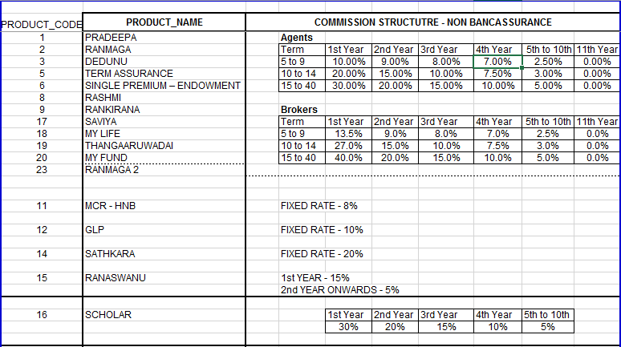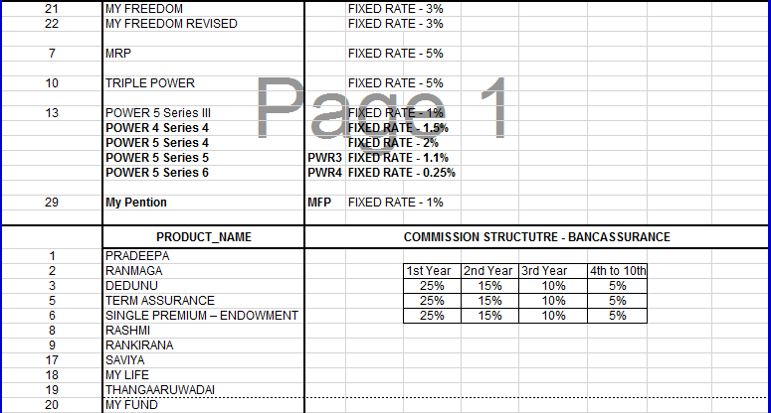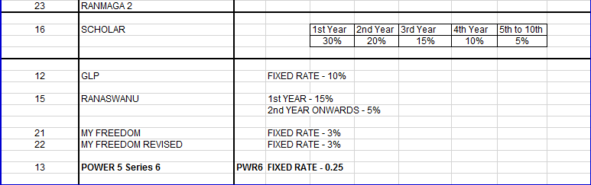

* + - 1. **Commission Calculation Rate Chart - Alternative**

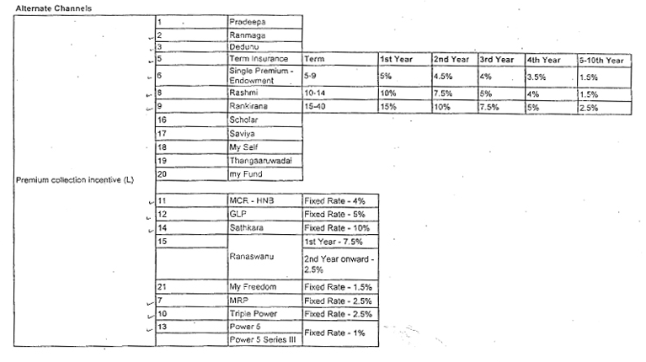

* + 1. **Overriding Commission Calculation Process**

An extra or additional commission, which paid to an agent or broker on business sold by subagents in his or her territory.

This happens from individual level to group level (E.g. from Field Advisor to GL or TL). In between individual level no overriding take place. Also there are some levels which cannot assign for overriding, system allows to configure those levels (Eg.GL to TL) and there is something called GAP which means overriding commission happens by passing levels.

With this module we are maintaining the hierarchy both horizontal and vertical because Some people has to wait long time to get a promotion because of their reporting level won’t allow since if they allow that they will miss the commission from the promoted party. So then even after the promotion we can assign a portion of the commission from promoted party to their previous superior.

* + - 1. Commission overriding rate chart

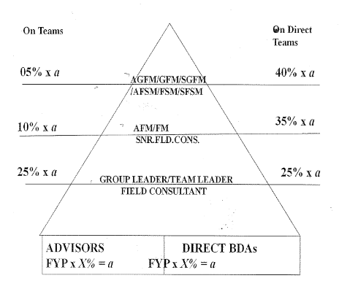

Example for proposed Commission overriding feature in graphically

According to the example GL or TL getting overriding commission from advisor as usual then the advisor promote to individual level (FC / AFC) after this GL/TL will not have overriding anymore as a solution for this we are implementing a feature for that GL/TL still can have some percentage of overriding commission. (Percentage still not decided)

?

FC / AFC etc…

GL/TL etc…

Promotion Current Overriding

Advisor

* + 1. **Incentive Management process**

Basically there are two incentive methods named as Bank Assurance & Field Staff incentives. In the Bank Assurance incentive method currently there are two incentive schemes as follows. As well as field staff incentive process can bifurcate such as Individual and Group paths. Under these two categories there are allowance types such as FST allowance, Target allowance, Retainer allowance, Advisor development allowance etc… also there are some defined levels such as GL, TL, SFC, FC, FSM and by considering all those given Categories, Allowance Types, Levels there are several calculation tables which is describing under the Field Staff incentives.

* + - 1. **Bank Assurance Incentive Process**

1. Incentive scheme for BAO’s

* Minimum achievement of NOP for the month 3, 4, 5 etc…
* Compulsory except for BAO’s less than one year

|  |  |
| --- | --- |
| NBP (FST + FYP) | Reimbursement of Business expenses |
| Achievement 80% - 100% | 1% of the NBP Achievements |
| Achievement 100% - 110% | 2% of the NBP Achievements |
| Achievement 110% - 120% | 3% of the NBP Achievements |
| Achievement 120% & Above | 4% of the NBP Achievements |

1. Incentive scheme for Executive

10% overriding commission of the attached BAO’s incentives in the respective cluster in addition to receivable from their own branches.

**3.1.4.1. Field Staff Incentive Process**

Allowances Types can categorize as follows

* Individual
  + FST Allowance - Monthly Payment
  + Target Allowance - Yearly Payment
* Group
  + Retainer Allowance - Monthly Payment
  + Retainer bonus allowance - Yearly Payment
  + Retainer arrears - Yearly Payment
  + Advisor development allowance - Monthly Payment
  + Group achievement - Monthly Payment

**Individual**  **Group**

Senior Group Field Manager

Senior Financial Services Manager

Group Field Manager

Financial Services Manager

Assistant Group Field Manager

Assistant Financial Services Manager

Field Manager

Senior Field Consultant

Assistant Field Manager

Field Consultant

Senior Field Executive

Senior Insurance Advisor

Field Executive

Insurance Advisor

Senior Insurance Advisor

Insurance Advisor

* + - 1. **FST Allowance (Individual)**

Advisors who are within 1st year from the date of appointment will get a FST allowance on a monthly basis, Maximum allowance will be Rs. 2500 (Configurable). After one year of the service period they will continue to enjoy the existing Target allowance.

|  |  |  |  |
| --- | --- | --- | --- |
| **No** | **Policies** | **FST Amount** | **FST Allowance** |
| 1 | 2 | <5000 | 750 |
| 2 | 2 | <7500 | 1000 |
| 3 | 2 | <10000 | 1250 |
| 4 | 2 | <12500 | 1500 |
| 5 | 2 | <15000 | 1750 |
| 6 | 2 | <25000 | 2500 |

* + - 1. **Target Allowance (Individual)**

|  |  |  |
| --- | --- | --- |
| **For the Month** | **Rs.** | **Allowance Rs.** |
| On Achieving MCFP | 7500 | 1000 |
| Additional MCFP | 2500 | 250 |
| FYP of | 25000 | 1000 |
| Addition FYP of | 10000 | 500 |

* Insurance advisor & Senior Insurance Advisor

|  |  |
| --- | --- |
| Insurance Advisor | Rs. 480000 |
| Senior Insurance Advisor | Rs. 720000 |

* Field Consultant

Annual New Business Premium (NBP) Target – 1.5M.

* Senior Field Consultant

Annual New Business Premium (NBP) Target – 2.0M.

* Assistant Financial Service Manager

Annual New Business Premium (NBP) Target – 3.0M.

* Financial Service Manager

Annual New Business Premium (NBP) Target – 4.0M.

* Senior Financial Service Manager

Annual New Business Premium (NBP) Target – 5.5M.

* + - 1. **Group Path Level Procedure**

Field Executive - GL

* Retainer allowance will base on monthly and cumulative achievement and will be paying the allowance on every month end. Maximum allowance will be Rs.6500/-.
* Retainer Bonus will be paying on every year end base on the highest achievement, maximum bonus will be Rs. 70200/-.
* Advisor development allowance will be 2500/-.

Senior Field Executive - TL

* Retainer allowance will base on monthly and cumulative achievement and will be paying the allowance on every month end. Maximum allowance will be Rs.9500/-.
* Retainer Bonus will be paying on every year end base on the highest achievement, maximum bonus will be Rs. 102600/-.
* Advisor development allowance will be 3500/-.

Assistant Field Manager (AFM)

* Retainer allowance will base on monthly and cumulative achievement and will be paying the allowance on every month end. Maximum allowance will be Rs.12000/-.
* Retainer Bonus will be paying on every year end base on the highest achievement, maximum bonus will be Rs. 129600/-.
* Advisor development allowance will be 4000/-.
* Group achievement allowance will base on cumulative group NBP achievement, maximum allowance will be Rs.8000/-.

Field Manager (FM)

* Retainer allowance will base on monthly and cumulative achievement and will be paying the allowance on every month end. Maximum allowance will be Rs.15000/-.
* Retainer Bonus will be paying on every year end base on the highest achievement, maximum bonus will be Rs. 129600/-.
* Advisor development allowance will be 5000/-.
* Group achievement allowance will base on cumulative group NBP achievement, maximum allowance will be Rs.9000/-.

Assistant Group Field Manager (AGFM)

* Retainer allowance will base on monthly and cumulative achievement and will be paying the allowance on every month end. Maximum allowance will be Rs.18000/-.
* Retainer Bonus will be paying on every year end base on the highest achievement, maximum bonus will be Rs. 194400/-.
* Advisor development allowance will be 6000/-.
* Group achievement allowance will base on cumulative group NBP achievement, maximum allowance will be Rs.10000/-.

Group Field Manager (GFM)

* Retainer allowance will base on monthly and cumulative achievement and will be paying the allowance on every month end. Maximum allowance will be Rs.22000/-.
* Retainer Bonus will be paying on every year end base on the highest achievement, maximum bonus will be Rs. 237600/-.
* Advisor development allowance will be 7000/-.
* Group achievement allowance will base on cumulative group NBP achievement, maximum allowance will be Rs.11000/-.

Senior Group Field Manager (SGFM)

* Retainer allowance will base on monthly and cumulative achievement and will be paying the allowance on every month end. Maximum allowance will be Rs.25000/-.
* Retainer Bonus will be paying on every year end base on the highest achievement, maximum bonus will be Rs. 270000/-.
* Advisor development allowance will be 8000/-.
* Group achievement allowance will base on cumulative group NBP achievement, maximum allowance will be Rs.13000/-.

## Group Incentive Criteria

## 

## 

## Retainer Bonus

* Only Direct Team NBP Achievement applicable for this

|  |  |  |  |  |  |  |
| --- | --- | --- | --- | --- | --- | --- |
| GL | Achievement % | 110-124.99 % | 125-149.99 % | 150-174.99 % | 175- 200 % | >200% |
|  | Bonus | 9000 | 15000 | 30000 | 58500 | 70200 |

|  |  |  |  |  |  |  |
| --- | --- | --- | --- | --- | --- | --- |
| TL | Achievement % | 110-124.99 % | 125-149.99 % | 150-174.99 % | 175- 200 % | >200% |
|  | Bonus | 17100 | 28500 | 57000 | 85500 | 102600 |

|  |  |  |  |  |  |  |
| --- | --- | --- | --- | --- | --- | --- |
| AFM | Achievement % | 110-124.99 % | 125-149.99 % | 150-174.99 % | 175- 200 % | >200% |
|  | Bonus | 21600 | 36000 | 72000 | 108000 | 129600 |

|  |  |  |  |  |  |  |
| --- | --- | --- | --- | --- | --- | --- |
| FM | Achievement % | 110-124.99 % | 125-149.99 % | 150-174.99 % | 175- 200 % | >200% |
|  | Bonus | 27000 | 45000 | 90000 | 135000 | 162000 |

|  |  |  |  |  |  |  |
| --- | --- | --- | --- | --- | --- | --- |
| AGFM | Achievement % | 110-124.99 % | 125-149.99 % | 150-174.99 % | 175- 200 % | >200% |
|  | Bonus | 32400 | 54000 | 108000 | 162000 | 194400 |

|  |  |  |  |  |  |  |
| --- | --- | --- | --- | --- | --- | --- |
| GFM | Achievement % | 110-124.99 % | 125-149.99 % | 150-174.99 % | 175- 200 % | >200% |
|  | Bonus | 39600 | 66000 | 132000 | 198000 | 237600 |

|  |  |  |  |  |  |  |
| --- | --- | --- | --- | --- | --- | --- |
| SGFM | Achievement % | 110-124.99 % | 125-149.99 % | 150-174.99 % | 175- 200 % | >200% |
|  | Bonus | 45000 | 75000 | 150000 | 225000 | 270000 |

## 3.2 Objectives

### 3.2.1 Design Diagrams

#### 3.2.1.1. Flow Chart

3.2.1.1.1. Flow chart 01 - Defines the main process of agent and Banc Assurance management module

**Agent Process** **Banc Assurance Process**

Start

Start

Get details From HR system

View Agent File

Update BAO details

Update Agent personal / other details

End

Update Agent level details

Update Agent ISS, Retainer Details, Terminations, Transfer Branches, Leader given dates etc…

End

3.2.1.1.2. Flow chart 02 – Define the process of data gathering for commission calculation

Start

For the month Transferred Sys Vouchers

For the month Cheque returns, reversals, Cancellations

For the month Manual receipts

For the month TCS receipts

For the month opening balance

PID List

Proposal number updates by policy no (Using Unadjusted Report)

Update Cheque returns/Refunds/ Reversals/ Cancellation

Update Sys vouchers

Update PID Balance

Check matching Receipts

Commission calculation with transaction codes (FST/FYP/RNW)

Yes

No

End

3.2.1.1.3. Flow chart 03 – Define the process of commission calculation

Commission calculation with transaction codes (FST/FYP/RNW)

Get Date Range for promotions and separate rate charts

Get Agent Type Detail – Agent / Broker

Get Term Detail – 5-9/10-14/15-40

Get Time Slab – 1st year / 2nd year

Get BA / NBA

Get Product Code Detail – Pradeepa/Ranmaga



Get Risk Detail – Spouse / Child

Get Cover Detail – TPPD / Hospital Cover

Get Rate chart Details

Calculate Commission using relevant rate details

End

3.2.1.1.4. Flow chart 04 – Define the process of Commission Overriding

Start

Get Calculated Commission Agent wise

Check Commission overriding Rates / Gap rule details

Calculate Overriding Commission

End

#### 3.2.1.2. User Interface Designs

* + - * 1. Agent Personal Details

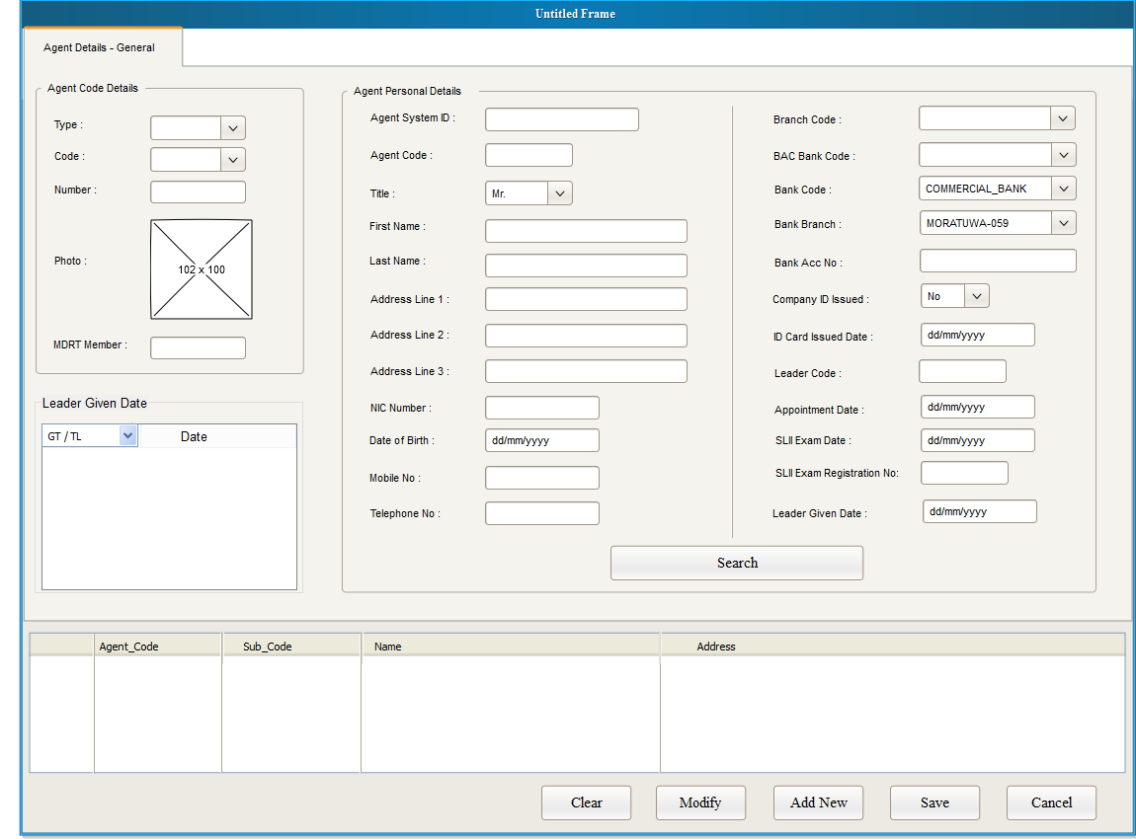

* + - * 1. Agent Other Details

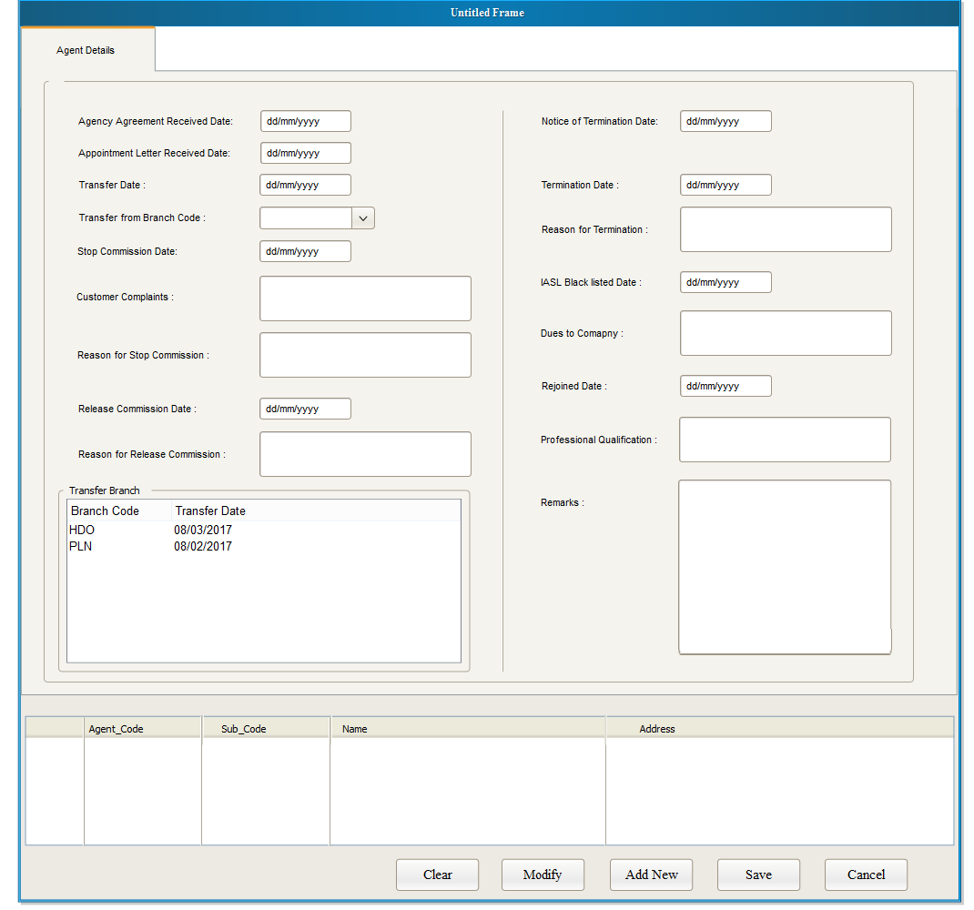

3.2.1.2.3. Agent Level Details

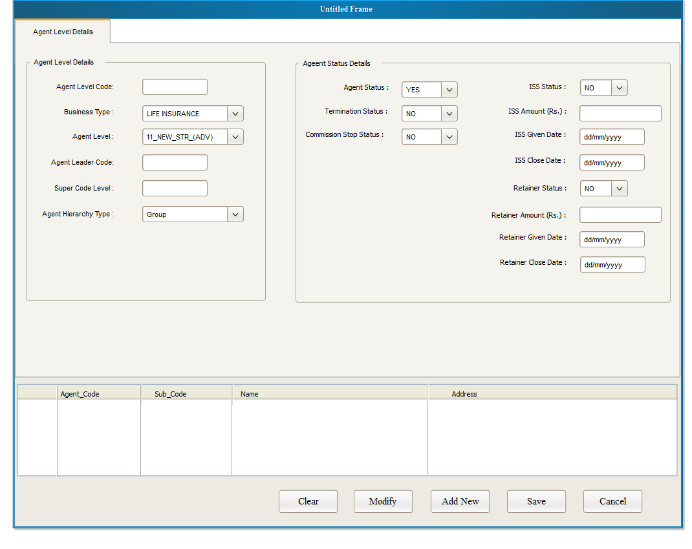

Interface 03 – Document upload and viewer

3.2.1.2.4. Commission Rule Define Interface

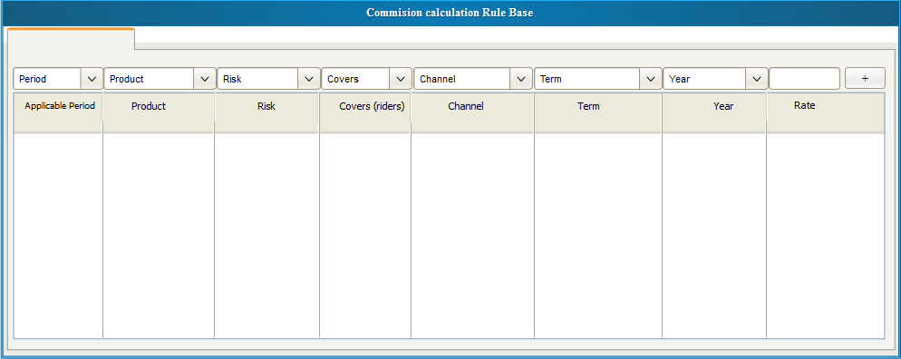

3.2.1.2.5. Commission Overriding Rule Define Interface

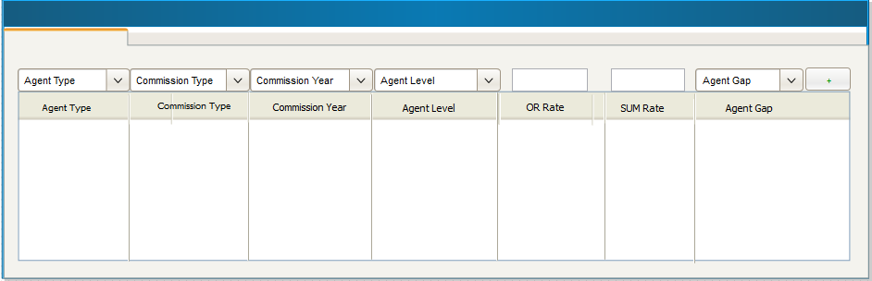

**3.3.** Reports

Servicing unit reports List - (Date Range)

1. Commission Admin Expense GWP NON BAC
2. Commission Admin Expense GWP BAC
3. Cheque Returns Report
4. Refund Report
5. Main Data Base Report
6. Main Data TME
7. PID Life
8. NONBAC Advisor Commission statement
9. TME Commission Statement
10. Transfer Summery
11. BAC Advisor commission statement
12. Opening Balance Statement
13. Refund / Cheque Return Schedule

Marketing Reports List

1. Advisor  Direct team report
2. Advisor Group  team report
3. Advisor main report
4. Advisor  report with date range
5. Policy report with date range  (Branch MIS)
6. Mobile numbers List
7. Title Mr./Mrs.- List from Gender
8. Stop commission reason List
9. Termination reason  List
10. Black list details List
11. Recoveries List
12. Preference Language

## 3.4. Other System Data

## 

This system is working based on TCS data and few other systems. This will be calculating the agent commissions and incentives by taking TCS receipts (sys vouchers) & other systems DPTS details.

Start

Get MRP/MCR DPTS

Get My Pension DPTS

Get Super Five DPTS

Get Investment DPTS

Get Takaful DPTS

Get My freedom DPTS

Check matching Receipts

Commission calculation with transaction codes (FST/FYP/RNW)

Update PID Balance

End

## Unsolved issues

1. TCS APIs is pending for to integrate New Commission app and TCS agent module.
2. Pending reports formats.

## Assumptions

* TCS will be providing APIs for **real time** communication with Agent management module so that we would be able to avoid duplicate agent detail feeding such as,
  + New advisor code entry
  + Advisors reinstate
  + Team reallocation (leader code change)
  + Bank Account details changes
  + Advisors’ Branches change
  + Advisors’ demotion details
  + Advisors’ basic details changes
  + Advisors’ status changes (Stop and Release Commission etc.)
* Cover level (Rider Level) commission will be calculating same as overriding commission calculation process since this is for extra covers and payment goes as an additional commission.
* For Non-TCS products, Until they come to systems (Applications) we have to continue the same process as now.(Upload DPTS files to new commission application)
* Please note that given interface designs may change when the time of implementation so please use those only for understanding purpose. Also For the incentive scheme there are no interface designs and flow charts given and there are more interfaces will be there more than attached.
* Reports Formats and all will be getting from the respective units.

## Annexures

|  |  |  |  |  |  |
| --- | --- | --- | --- | --- | --- |
| **Responsible For** | **Name** | **Designation** | **Recommended/**  **Approved** | **Date** | **Signature** |
| Agent Management & Incentive System | Mr. Nishantha Dissanayake | Executive – Life Distribution | Recommended |  |  |
| Agent Management & Incentive System | Mr. Pathum Fernando | Executive – Life Distribution | Recommended |  |  |
| Agent Management & Incentive System | Mr. Tharindu Munasinghe | Assistant Manager  -  Distribution | Recommended |  |  |
| Commission System | Mr. Harshana Aponsu | Manager –  Life Supporting Service | Recommended |  |  |
| BA Incentive System | Mr. Ranjeewa Gunawardena | S. Executive  -  Distribution | Recommended |  |  |
| BA Incentive System | Mr. Madhawa Gunarathne | Manager Banc assurance | Approved |  |  |
| Commission System | Ms. Geethani Saram | Head of  Life Supporting Service | Approved |  |  |
| Overall System | Mr. Ivan Nicholas | Chief Business Officer | Approved |  |  |
|  |  |  |  |  |  |